Lab – To learn some basics for how to use VS Code for PowerShell.

**To Download the Extension PowerShell on VS Code:** Click on the “Extensions” icon in the activity bar and search PowerShell. Select the latest version and hit the install button.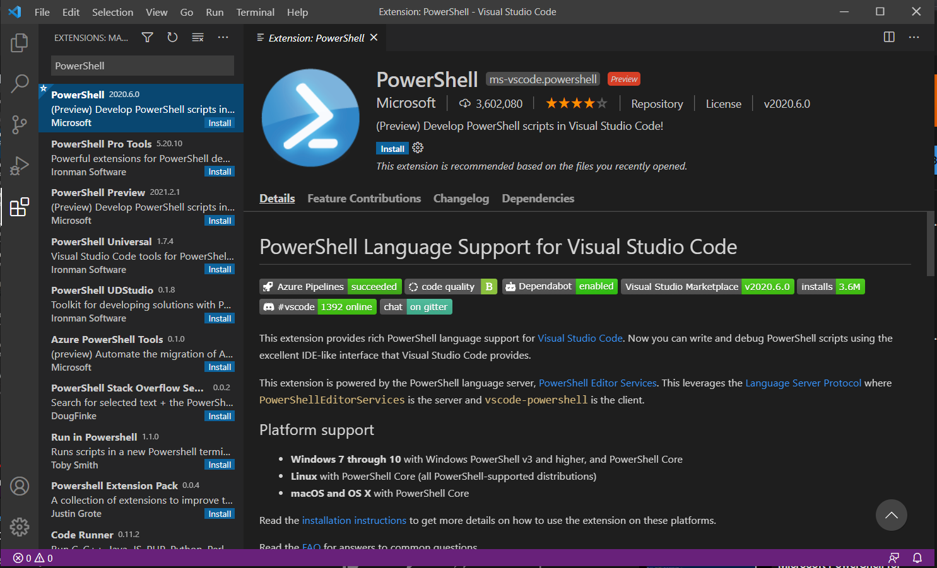

**Setting up of PowerShell:** Once the installation is done it will ask you “Do you want PowerShellGet to install and import the Nuget provider now?” enter ‘Y’. It will start setting up the PowerShell.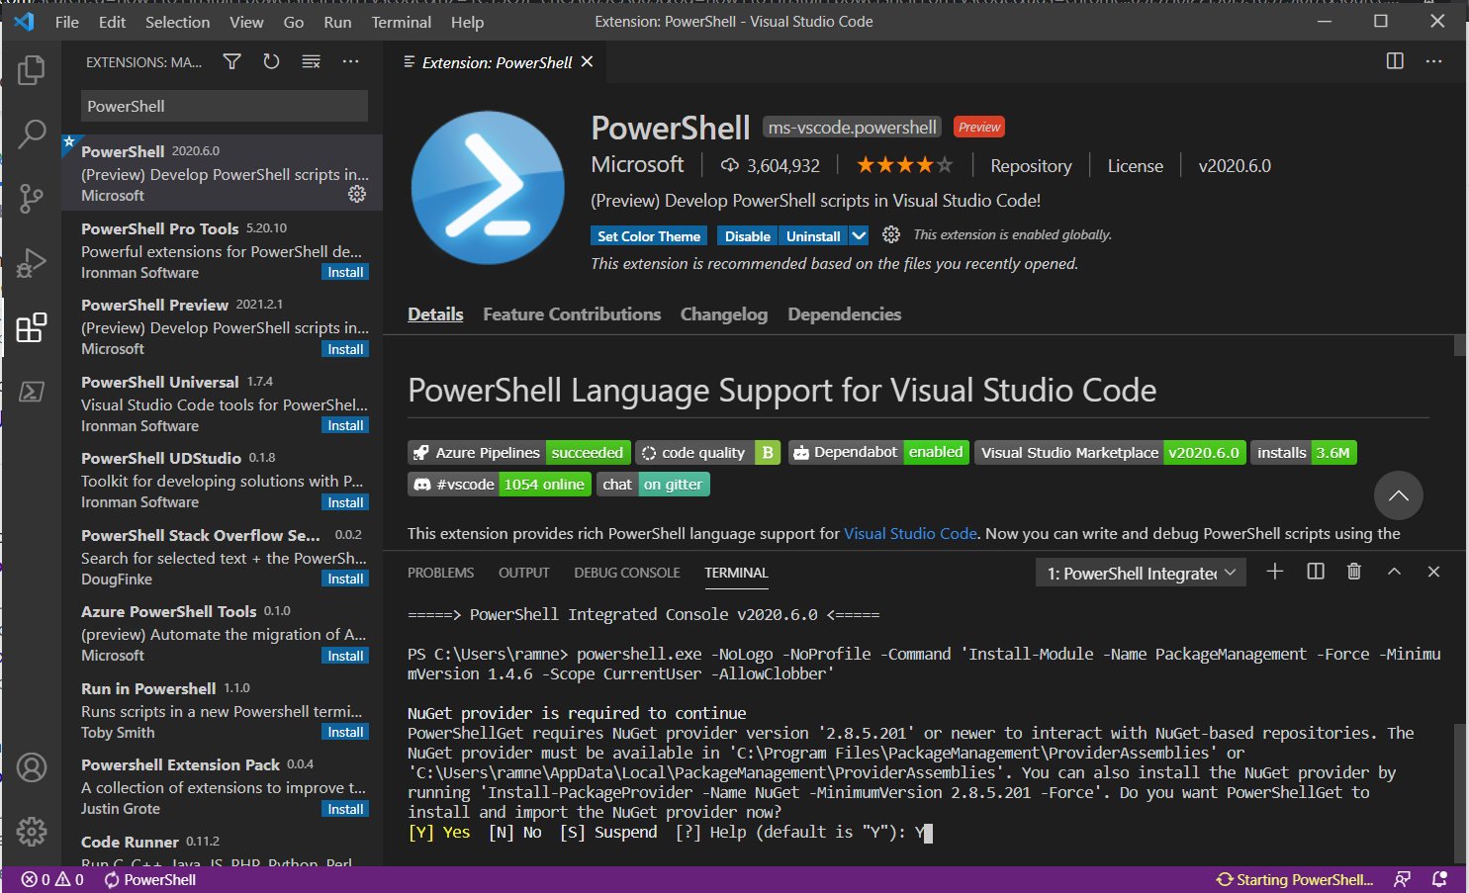

**IntelliSense completion of commands:** Create a new file and name it “demoExercise” with extension .ps1 for PowerShell. Learn about some autocompletion of code Type in get- and you can see all commands stating with get.

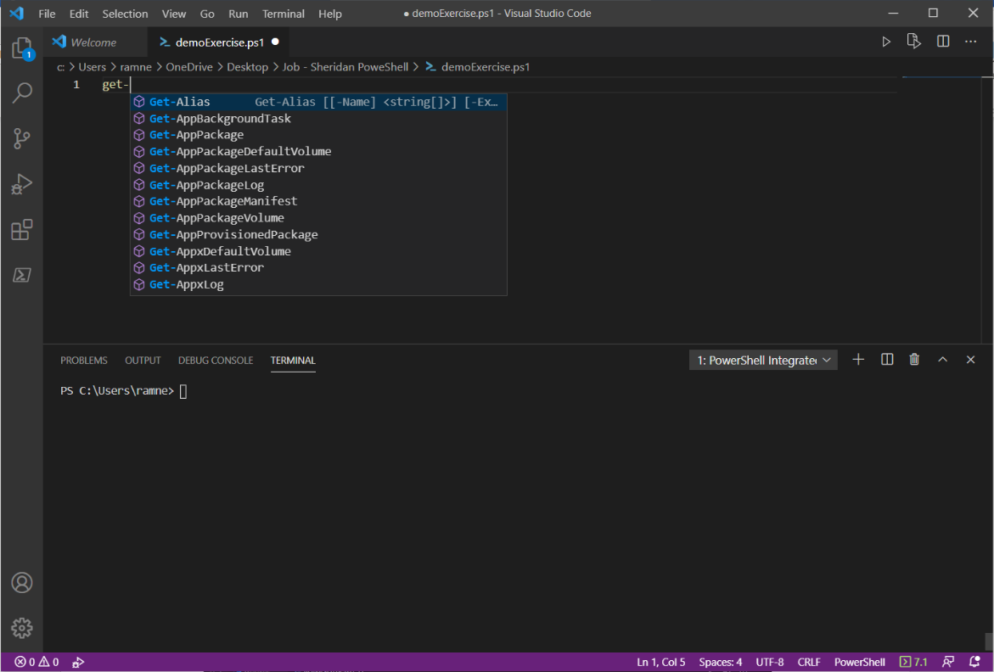

**To run the code and check results:** Enter Get-Alias and press F5 key to run the code or press the small arrow symbol on the top right corner. After running the code, the results are shown in terminal. Open terminal from the Terminal. To clear the terminal just write “clear” inside the terminal.

Run the code

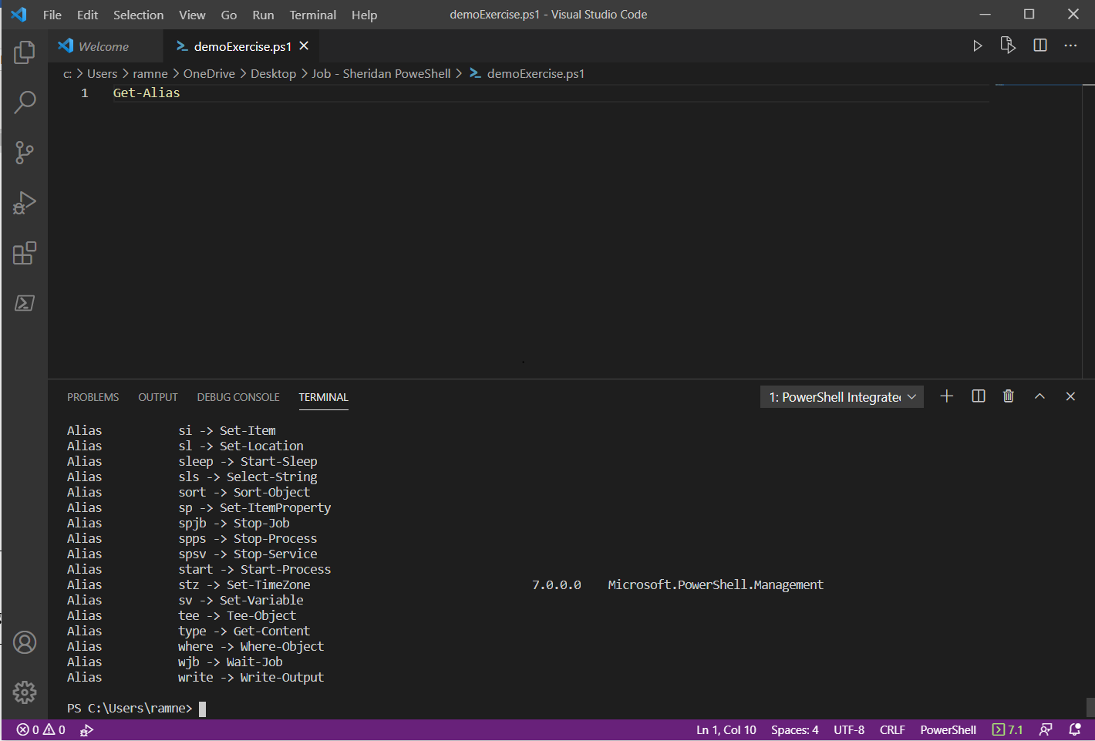

Errors and Warnings

Programming Language and version

Current line number

**Shortcuts:** Try some shortcuts on VS Code. Type in gps and a yellow bulb like symbol will appear there. Hover over the symbol and it will show you options like “Replace with Get-Process”, that will change the short form into the actual command “get-process”. Hit F5 key to run the command.

